Hello  
I’m Daniel omotehinse

12 lamino estate, oke-eletu

Ikorodu, Lagos state

**(234) 09056207788**

[**omotehinse99@gmail.com**](mailto:omotehinse99@gmail.com)

Summary

I'm a Passionate and dedicated full stack Developer (Major in Backend development) with over 3 years of experience in Node.js development. Strong foundation in JavaScript and TypeScript, with a FreeCodeCamp certification in JavaScript and Node.js backend. Proven ability to develop and maintain scalable, high-performance backend systems. Eager to leverage my skills and experience to contribute to a dynamic tech company.

# Skills

* Programming Languages: JavaScript, TypeScript , HTML,CSS, Bootstrap
* Backend: Node.js, Express.js
* Databases: MongoDB, PostgreSQL, MySQL
* Version Control: Git, GitHub
* Other Technologies: REST APIs
* Tools: Visual Studio Code, Postman,insomnia

# Education

## October 2010 - April 2012

### Livingstone model college, ikor*odu - junior secondary school*

April 2012 - April 2015

**Supreme senior secondary school** , ikorodu - senior secondary school

December 2019- till date

* **Adekunle Ajasin university akungba Akoko, bachelor in science**

# Certificate

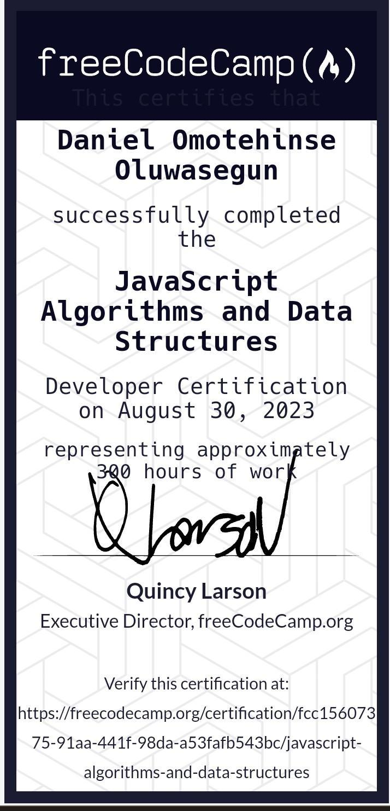

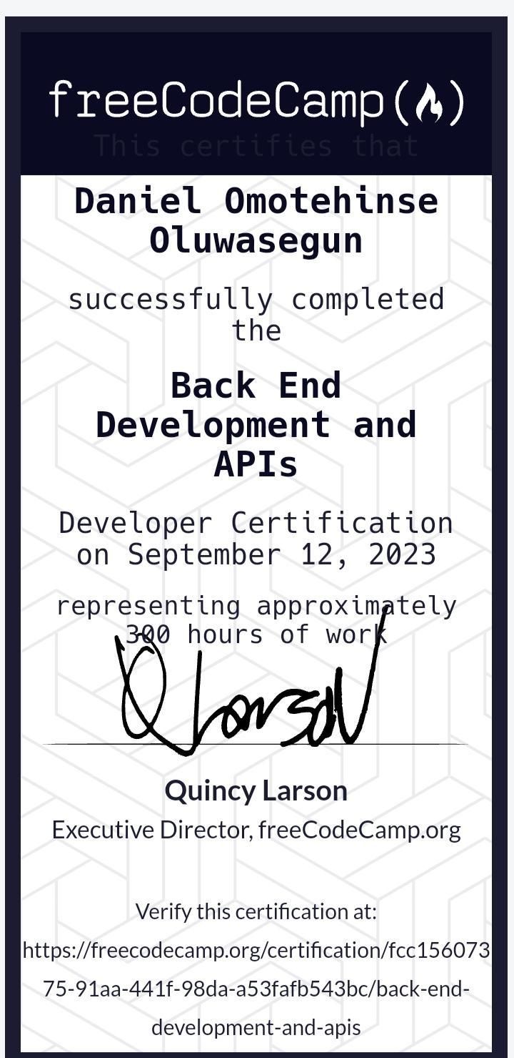

Social media handles

**WhatsApp : +2349056207788 ,**

**X : @Dahnilo_99 ,**

**Facebook: Daniel omotehinse**

**GitHub: @danyboy99.**

**Experience**

Freelance Backend Developer

Duration: 03/2024 - Present

Responsibilities:

Develop and maintain backend systems using Node.js and Express.js.

Design and implement RESTful APIs for various applications.

Collaborate with frontend developers to integrate user-facing elements with server-side logic.

Optimize application performance and troubleshoot issues.

**Eedu.tech software dev& tech support**

**Duration: 1 January 2025 - presents (par time)**

**NoResponsibility:**

**Maintain application, and all tech support for the customer ( on how to use the app and if there is any issues)**

**Freelanced project:**

<https://osi-ekiti.com/>

https://poultry-management-system-ya7l.onrender.com/

**Personal project (live)**

<https://danilo-store.onrender.com/>

<https://nine9gistblog.onrender.com/>

<https://student-evaluation-system-ceps.onrender.com/>

<https://shop-with-99-api.onrender.com>

Portfolio

<https://danyboy99.github.io/>

<https://danyboy99.github.io/99solution-digital-services/>

**GitHub repository**

https://github.com/danyboy99/Danilo_store.git

https://github.com/danyboy99/99gistblog.git

https://github.com/danyboy99/student_evaluation-system.git

https://github.com/danyboy99/shop_with_99_api.git

https://github.com/danyboy99/Dollar_exchange_api.git

<https://github.com/danyboy99/banking_system.git>